**Unsupervised learning**

**Introduction of the unsupervised learning**:

Unsupervised learning is a method of machine learning, which can automatically classify or group the input data without giving the premarked training examples. The main applications of unsupervised learning include **cluster analysis**, **association rule** and **dimension reduction**.

**Method:**

**k-means clustering**: A method originated from signal processing is more popular in the field of data mining as a clustering analysis method. The purpose of K-means clustering is to divide n points into K clusters, so that each point belongs to the cluster corresponding to its nearest mean, and take it as the standard of clustering.

**Mixture model**: It is a probability model used to represent the existence of the Central Asian population.

**Anomaly detection**: Identification of items, events, or observations that do not conform to the expected pattern or other items in the data set. Under the assumption that most of the instances in the data set are normal, the unsupervised anomaly detection method can detect the exceptions of unmarked test data by finding the most mismatched instance with other data.

**Compared with supervised learning:**

In supervised learning, there are labels. They are the expected results in the algorithm. The common tasks are classification. Like the spam filter, the filter gets a e-mail, and it will know whether it belongs to normal mail or spam.

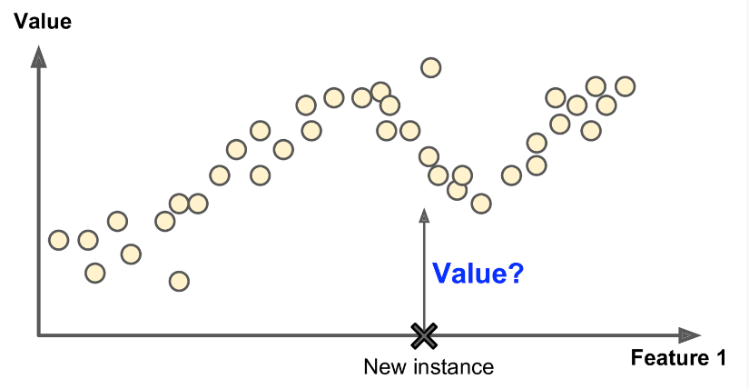

Training data for unsupervised machine learning is not labeled. The system will try to learn by itself. For example, if you have a website, you have a lot of data about your website visitors. You can use clustering algorithm to try to group similar visitors, and the algorithm will find the association between visitors. For example, it may find that 40% of the visitors are male. They like comics and usually read your articles at night. 20% of them are young science fiction fans and often visit your website on weekends.

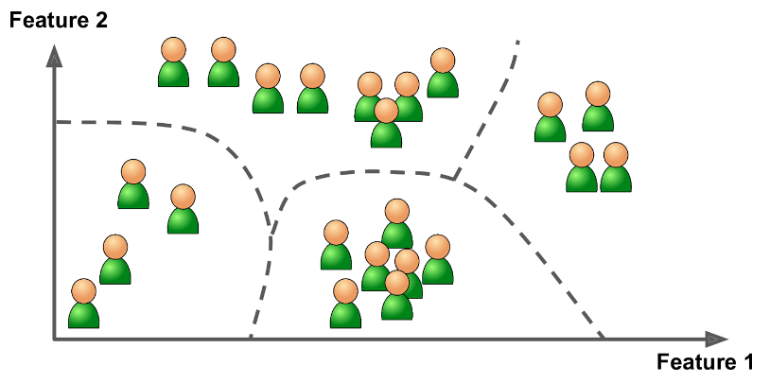

Reference: 《Hands-On Machine Learning with Scikit-Learn and TensorFlow》by Aurélien Géron